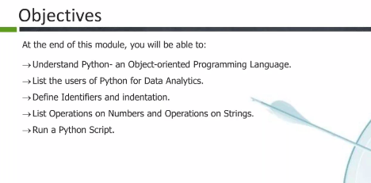

Web dev framework – Django, flask, jdpie …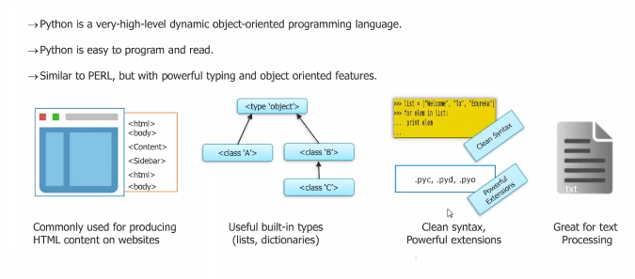

Dynamic, strongly typed , interpreted ,compiled

Scripting,..development…

Os level , batch programing, network programing..by its own also can use thir patry open source code

Commenting

# single line comment

“”” multiline comment “””

‘’’multiline’’’ // this is also known as doc strings

Literal contants

Types of numbers

Int, float

Int num with no decimal point

Long int float

Final answer will go with higher order hierarchy

Octal - starts with 0

Hexa – starts with 0x

Complex number

_a 🡺 private

_ _ a